Nepal College of Information Technology
Assessment
Spring 2012
Program : BE Time : 3 hrs
Semester : Spring (IV) FM : 100
Subject : Engineering Math-IV PM : 45

- Candidates are requested to give their answer as far as practicable in their own words.
- The figure in the margin indicates the full marks
- Attempt ALL question

1. a) Show that the necessary condition for analyticity of a function 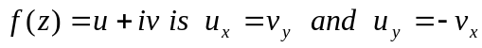 8
b) State and prove Cauchy Integral formula.
Integrate 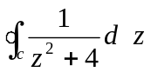 C: 4x²+(y-2)²=4 counterclockwise. 7
2. a) Define zeros and pole of a function f(z). Determine the location and order of the zeros of the following functions:
i) 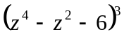
ii) 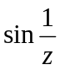 7
b) Find Z-transform of 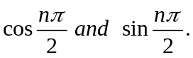 8
3. a) Show that 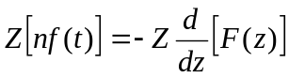 where F(z)=z[f(t)] and find 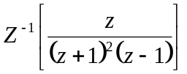 8
b) Solve the difference equation 7
4. a) Derive two dimensional heat equation and wave equation with required assumptions. 7
b) Find the solution of one dimensional wave equation corresponding to the triangular initial deflection.
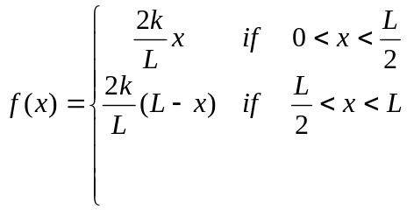
And its initial velocity is zero 8
5. a) Solve one dimensional wave equation 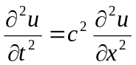 under the conditions i) u(0,t) =0 ii) u(L), t)=0 iii) u(x, 0)=f(x) and iv) 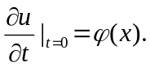 8
b) Find a tangent vector, unit tangent vector and tangent to the curve 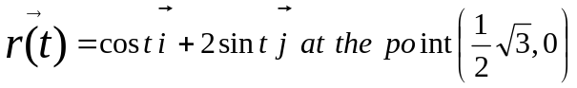 represent the curve x²+y²=1 parametrically. 7
6. a) Define convolution of two functions. State and prove convolution theorem on Fourier transform. 7
b) Find the Fourier transform of
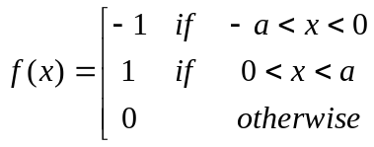 8
7. Attempt all 2*5=10
a) If u=x³-3xy², Show that u is harmonic.
b) Find z(1) and z(-1)^{n}
c) Prove that f_{c} (af+bg) = af_{c} (f)+bf_{c} (g) where f(x) and g (x) are function of x.
d) Evaluate 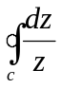 where c is the unit disk |z|=1
e) Find Z(n3^{n}).

